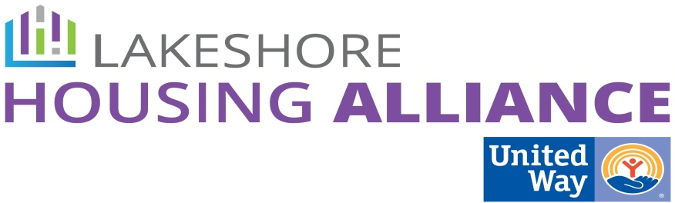****

**Case Management**

July 8, 2:30 PM

Department of Health and Human Services

12185 James St

Holland

**Present:** Carrie Benchich, Jennifer Boerman, Karen Reenders, Brian Vork, Holly Seymour, Christen Korstange, Kendra Spanjer, Jody Immink, Lindsey Ajega, Kaite Appold, Linda Bazan

1. **Welcome and Introductions**
2. **Pathways Project**

* Designed after the Muskegon Health Project which has created a number of pathways that engage 43 community health workers (trained in the pathways) and embedded in the places where people seek services. United Way always asks the question: Where do we find people and plug them into reasonable services?
* Next steps: Expand the MHP into northern Ottawa County by placing a CHW at three different locations – NOCH ER, TCM, Love INC.

1. **What are the Best Practices in Case Management?**

* Open and frequent communication -
  + CM > Client
  + Open means client can express themselves and get an honest answer.
  + Frequent means to be clear about expectations
  + Communication based on the client needs though face to face is the best
  + Who is good at this?
    - The People Center
    - DHHS – some staff is available to clients
* Ability to identify or locate resources - **JODY**
  + Case managers need to be aware of services. Where is this happening?
    - Case Cooordinator/Collaborator Meetings – informational updates and request for resources for unmet needs
    - Call-211
    - Whole Family Connection
    - Know Book
    - Google
* Meeting clients where they are especially if they are homeless
  + Case management located with the client
  + Currently blended countywide. But is home or office best practice? Or both?
* Balance between guidance/mandatory/empowerment
* Partnering with clients
* Develop the individual client strengths to create plans with the client instead of **for** the client (Strength-based case management) - **CARRIE**
* Working to reduce isolation, build on social (personal) support networks - **BRIAN**
* Create long term housing goals for sustainability
* Reduce crisis and increase self-sufficiency
* Empowering clients to be independent
* Appropriate staff client boundaries -
* Appropriate caseloads, staff prepared and supported - **HOLLY**
  + Affects open and frequent communication
  + What is reasonable Staff to Client ratio?
* Triage standardized -
  + Good Sam uses SPDAT, a vulnerability index
  + Links to caseload limits
  + Create a standard tool for those who don’t have one.
  + Panel-CM’s meeting schedule
* Speak the language and culture competency
* Best practices are related to other strategies:
  + Coordinated case management
  + Share common information among agencies
  + Shared/standardized data gathering
  + Identify centralized intake and triage
  + Consistency among case workers
  + Standardized procedures

1. **How might you identify households who are approaching a crisis?**

* Capture them for their housing needs before there is a housing crisis at a food pantry, utility assistance, jail, CPS, DV, divorce, DHS, free health care
* Hard to get people to address a need in the future.
* Education early on.
* Engaging people a little bit differently. Build relationships via practical and concrete assistance.

1. **ACTION PLAN**

* Group members will write up short descriptions of the following:
  + Triage standardized –
  + Ability to identify or locate resources - **JODY**
  + Appropriate caseloads, staff prepared and supported - **HOLLY**
  + Develop the individual client strengths to create plans with the client instead of for the client (Strength-based case management) - **CARRIE**
  + Working to reduce isolation, build on social (personal) support networks - **BRIAN**

1. **Next Meeting**

* What is the best delivery model for the Best Practices?
* Within 4 weeks - Lyn will create a Meeting Wizard