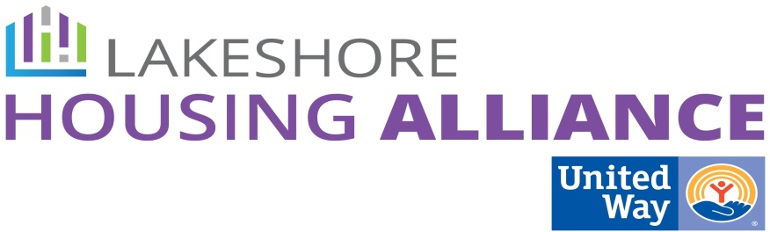****

**Housing Trust Fund**

October 6, 2015

3:00-4:00

Fillmore Complex

Minutes

**Present:** Paula Huyser, Marge DeBlaay, Kristy Keever, Sue Harder, Liz DeLaLuz, Lyn Raymond, Patrick Moran, Al Vanderberg

1. Summary of work to date

Lyn reviewed the summary of work to date for the housing trust fund and introduced the infomurals.

2. If there was a sustainable Housing Trust Fund, what would you do?

**Highlighted items are the top four choices**

Creating new affordable housing units

**Down-payment assistance for homebuyers**

Assist or augment supportive housing services

Housing for seniors

Supportive Housing for mentally ill persons

**Rehabilitation of existing units**

**Build a “neighborhood” of mixed income**

Help people move from subsidized housing

Supportive Housing for Homeless

Supportive Housing Developmentally Disabled

**Rebate for pre-development cost for affordable rental housing units**

Housing subsidies for current workers in the community.

Loan guarantees for development of affordable rental units.

Incentives for developments of accessible rental units

Leverage state housing trust fund dollars

Create efficiency units

Create accessory dwelling units

**Developer fees to build low income units**

**Rent Assistance**

Developers incentivized to make rents low.

Guaranteed security deposit.

Be the lender to lower the cost of buying

3. What possible revenue sources are realistic?

**Highlighted items are the top four choices**

**Land Bank**

Community Development Financial Institutions (CDFI) (Banks)

**Private/Corporate Donations**

* **Important to structure the product with support (financial and otherwise) from business leaders in order to get countywide support**

Countywide Millage

Local Millage

* Several current millages in the works

Document Recording Fees

* Can’t set recording fees – how are current recording fees used?
* Can those funds be

Real Estate Taxes

Condo Conversion Fees

Property Tax

Property Sales

Developer Impact Fees

* Tax on if above ALICE

Luxury fees of all kinds

Government Appropriations

**Michigan Housing Trust Fund**

Hotel/Motel Tax

**Grants**

Bond Funding

*Repayment of loan guarantee*

*Repayment of security deposit*

**Next steps:**

How do we make these resources sustainable?

Realtors need to be invited to Private/Non-Profit Partnership

How do CDFI’s work?