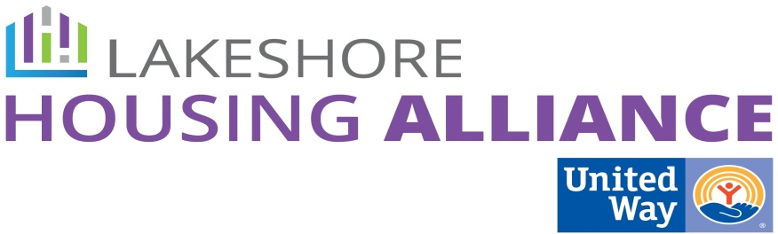****

**Private/Non-Profit Partnership**

**Landlord/Tenant Barrier Removal Project**

1. Identified Barriers to both landlords and tenants

For Tenants / For Landlords

* Housing Cost
* Negative Background Check
  + Criminal History
  + Credit Report
  + Poor Rental History
* Income too low to qualify
* Housing Stock
* Voucher rate doesn’t match current FMR
* Stock Type (family size)
* Not enough intensive Housing Search Assistance
* Security Deposit
* Utility Deposit
* Pets
* Not guaranteed money
* Too many applicants – how to pick?
* Stigma/Experience
* Cost of upkeep of rental
  + Possible grant access if you have low income renters (for property improvement / repair)
* Risk to property
* Utility Deposit
* Lack of on-time payment history
* No potential for long term stability (no long term employment)
* Rising expenses

1. Next steps:

* Check on already existing programs.
  + City of Holland
  + CAA Weatherization
* Talk with Property Management companies
  + HHI Management
  + Ben VanderWoude
  + Good Samaritan Ministries
  + IPA (development and management)
* Ask:
  + Which of these things do you already do?
  + Would you be able/willing to increase capacity to add what you don’t do?
  + What would you need to operate/how much will it cost? Staffing, etc.