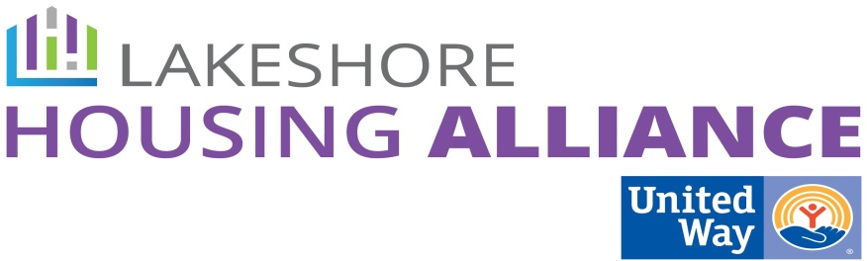****

**Private/Non-Profit Partnerships Work Group**

Tuesday, June 23, 2:30 – 4:00

Center for Women in Transition

411 Butternut, Holland

**Present:** Linda Jacobs, Kelley Pasatta, Charisse Mitchell, Lyn Raymond, Beth Larsen, Joel Dye, Rick Mannes, Liz DeLaLuz, Anna Bednarek, Mark Wolfe, Nate Schipper, Linda Bazan, Jane Johnson, Patrick Moran

1. **Welcome and Introductions**

* Charisse welcomed the group and facilitated introductions.

2. **Review Project Drafts**

* Patrick reviewed the process thus far, introducing the draft concepts that resulted from the first work group meeting.
* Employer Assisted Housing
  + Households instead of “working families”
  + Wraparound should include other supports besides financial stability. Remove “financial stability” and replace with “household.”
  + Second bullet: add “eliminate barriers” only transportation.
  + ADD: third bullet “in mixed income concepts/neighborhoods”
  + Acquire and/or build
  + Private/Non-Profit Partnership instead of OHN.
  + Is this charitable? Is it part of the employee benefit package? What happens when someone gets laid-off?
  + Commit to a lens of empowerment. Address mixed-income, change in the paradigm.
  + Property Manager needed
  + Itemize barriers in program detail (transportation, child care)
* Business Leader Education
  + Benefits – will effect employee recruitment and retention. Make the business case, tailored data.
  + Need data about wages. Maybe employers would like to increase wages.
  + Consistent messaging is important. Make them aware before it is presented. Create some buzz…
  + Establish a broader marketing project that reinforces the concept.
  + How many employers are we talking about and shoot for a percentage? Create a GIS map.
  + Approach Chamber and Rotary for example, LHRMA and LERN
  + Capture the voice of the employer.
* Risk Reduction Fund
  + Great Idea
  + What about the implications of stereotyping this population?
  + How do you create accountability on the part of the tenant? Do we need any accountability?
  + Financial harm is vague. Why would we cover damage if this population isn’t any more inclined to damage property?
  + What is the strategy here? Access to housing is the strategy and reducing barriers. Getting them in and maintaining housing.
  + Do we mean waiving security deposit or reducing barriers?
  + Landlord/Tenant Barrier Removal Project.
  + What about enforced savings (portion of rent saved over the course of tenancy)

3. **Next Steps**

* Start with *Business Leader Education* followed shortly by *Employer Assisted Housing* (though not technically priority 2) because the *Landlord/Tenant Barrier Removal Project* would be the easiest to implement.
* They are mutually reinforcing activities.
* **Start at the same time but progress at different rates.**
* **Clearly state target population: Between poverty and the ALICE threshold.**
* Contact Lyn with interest in one of the three strategies.

4. **Next Meeting**

* Lyn will gather input related to interest groups and then will schedule meetings.