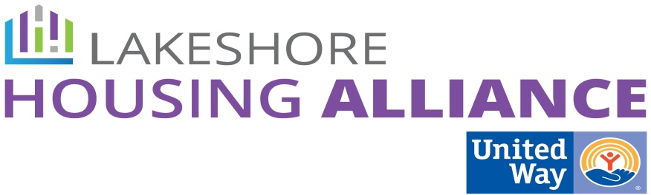****

**Private/Non-Profit Partnerships Work Group**

Tuesday, October 20, 2:30 – 4:00

Center for Women in Transition

411 Butternut, Holland

Minutes

**Present**: Linda Jacobs, Ashley Rodriguez, Beth Larsen, Holly Johnson, Mark Wolfe, Chris Hofland, Amy Alderink, Jane Johnson, Liz De La Luz, Patrick Moran, Lyn Raymond

1. Welcome and Introductions

2. Review Project Proposals

Patrick reviewed all proposals.

* **Business Leader Education**
  + *Issues*
    - It will be a challenge to get retention numbers and number of employees below ALICE.
    - We’ll need household income to determine ALICE households.
    - Is it really needed?
    - Employer is more important than location
    - Confidentiality
    - Performance measures
  + *Opportunities*
    - Offer anonymous survey
    - Ask each CEO first
    - Run the idea for BLE by a couple of trusted CEO’s
    - Pilot 3 by industry/influence
    - LERN – Lakeshore Employees Resource Network
  + Housing Retention Study
    - Details to be worked out at sub-committee
* **Employer Assisted Housing**
  + *Issues*
    - Tie % of housing to % of investment
    - Is there a builder ready to go?
  + *Opportunities*
    - Time limit the “right of first refusal”
    - Mixed income affordable housing
    - Just give!
    - Pay back options for investors
* **Landlord/Tenant Barrier Removal**
  + *Issues*
    - Don’t use “property management” language.
    - How do we support both landlords and tenants and not just one side?
  + *Opportunities*
    - Proactively advertise units on existing websites.
    - Add quality of rental unit to Tenant barriers. Affects tenant/landlord relationship.
    - Add application fees to Tenant barriers.

3. Next Steps

Business Leader Agency

* Print more OHN documents and include updates
* Money for retention study
* Create performance measures
  + Sign on to a Level of engagement (have an *ask* ready)
  + How much or what?
  + Create opportunity list with benefits

Landlord/Tenant Barrier Removal Project

* Investigate already existing program, property managers and ask:
  + Which of these things do you already do?
  + Would you be able/willing to increase capacity?
* If none of the above, do we create a new “property management” company?

Employer Assisted Housing

* Check in regularly with the larger group.
* Find a builder/developer
* Holly will provide information about investment opportunities

What other groups may have interest in Employer Assisted Housing ideas that are not employers?