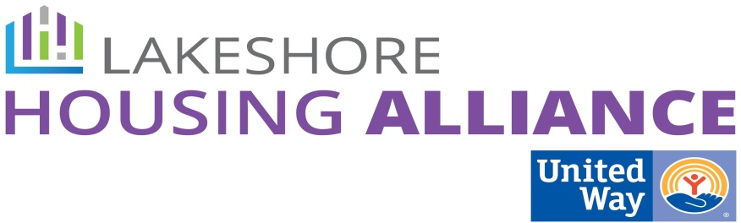****

**Tax Credits**

March 31, 9 AM

United Way

115 Clover

Holland

Present: Stacy Pacanowski, Lyn Raymond, Patrick Moran, Josh Ghena, Shirley Woodruff, Liz DeLaLuz, Marge DeBlaay, Sue Harder

Minutes

1. Welcome and Introductions

Josh welcomed the group and facilitated introductions.

1. Structure Review

* Patrick reviewed the process thus far and how Ottawa Housing Next is influencing the conversation around affordable housing.
* 9% Tax Credits are very competitive and written to address the greatest need. Ottawa County is comparatively lesser need. Focus on mixed income with 4% non-competitive tax credit. Challenging to get enough gap financing through MSHDA. County or City or other municipality can step in to provide gap financing as well.
* Developers will go to where the projects can be successful such as flexible zoning, city council support, PILOT
* Let’s change the “conditions of the pond” to overcome those barriers.

1. Initial Strategies Review

* Mapping
* A proposal has been submitted by the Community Research Institute for a GIS map. It will cost about $20,000 to complete. There is also conversation around a regional TMA with Kent, Allegan and other counties in Region 4 prosperity zone.
* Ryan Kilpatrick from MEDC quotes about $10,000 per community with MSHDA covering half of the expense. There are some economies of scale when multiple communities are involved. MSHDA has set aside funding for a ‘Region 4 TMA’ which we have the ability to define together. Where will this funding come from?
  + Is this a likely ask to be funded?
  + Are we offering them a tool they don’t already have access to?
  + Who is the end user of the product? Private sector developers, employers, government entities.
  + The value is combining all the information. Platform and approach is different and may be the selling point. Market analysis is important.
  + Follow-up with CRI to determine on-going costs after the 3 years
  + Very large philanthropic community in West Michigan.
* LIHTC Expirations
  + None of these projects will fall off the affordable rolls in the foreseeable future.
  + However, once the project is past the 15 year compliance it will need restricted money for capital improvements and will compete for the LIHTC. MSHDA has to balance creating new units and preservation of existing. Majority of MSHDA dollars are going into preservation. CAN (Capital Needs Assessment) required by MSHDA.
  + Another pool of money would be very valuable so that the two types of projects that compete for the same pot of money.
* Match Developers and Municipalities
  + What is our method for making these connections?
  + Creating a list of mission driven developers would be valuable.
  + Exploring whether developers have been looking at property in the county.
  + Create local competitions for property development outside of LIHTC for example.
  + The more information that can be given up front the better so the developer can make an educated decision about the property.

1. Rename/Combine groups

* Merge Inclusionary Zoning and Tax Credits and create a new name.

1. Next Steps

* GIS Map: Approach municipalities for funding first, then developers, banks, churches
* Explore other pools of money for improvements, etc. (tabled)
* Developers: What are the top ten things you need to know in order to pursue a project?
* Create list of developers – contact developers in the room.

1. Next Meeting

April 19, Boatwerks Event Center